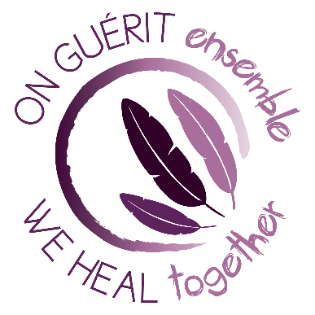

FIRST NATIONS ACTION PLAN
AGAINST SEXUAL ASSAULT
Created at the First Nations Forum on Sexual Assault, March 27 - 29, 2018

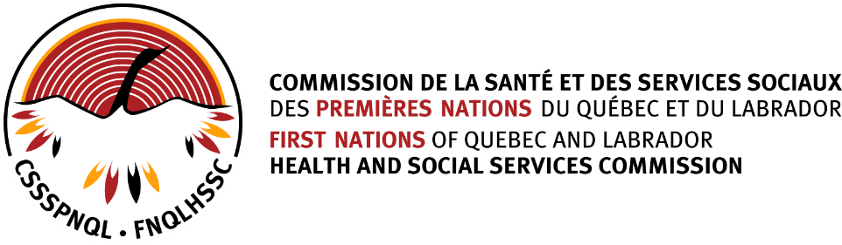
CONTEXT
The following document is the result of the working groups at the First Nations Forum on Sexual Assault, which took place from March 27th to 29th 2018 in Québec City. This Forum, organized by Québec Native Women in partnership with the First Nations of Québec and Labrador Health and Social Services Commission, was an opportunity to meet, exchange and collectively reflect on solutions to put an end to the problem of sexual assault within our populations. This major event, which lasted two and a half days, gathered approximately a hundred members from First Nations (political actors, health directors and intervention workers), coming from about thirty communities and urban centres across the province. The Forum included a presentation of the context around the problem of sexual assaults in Indigenous communities, stories of success, and work sessions on the action plan to fight sexual assault. It was an opportunity to commit together and act towards collective healing.
During the Forum, the participants worked in smaller groups to improve, modify and adapt a proposed action plan to fight sexual assault in First Nations, so that it could be used as a tool by communities. By the end of the Forum, the improved action plan was approved by all of the First Nations participants. This is the version you will find in this document.
This action plan is therefore a tool, a template. The objective is to allow communities who wish to develop their own local action plans to have a model on which to base themselves. Each First Nations community or group is free to adapt it to their realities and their cultures. You can download the Word version to makes modifications, or the PDF to use as it is.

VISION

In full respect of their respective cultural distinctions and identities,
  - Each First Nation community¹ is engaged in the recognition, reduction, prevention, and elimination of all aggressions of a sexual nature.
  - Concrete actions are in place to contribute to individual and collective well-being, while supporting victims, aggressors², and all other affected persons according to their respective needs.

NOTE:
- It is up to each community to determine what terms it prefers to use for naming any objective or committee in this action plan, or for debated the choice of terms like “sexual aggression” or “assault”.

^{[1]} Throughout the document, the word “community” is used to designate both First Nations communities (villages/reservations) and Indigenous people living in urban environments.
^{[2]} Throughout the document, we understand that victims or perpetrators can be anyone regardless of gender identity, gender expression or sexual orientation.

Guiding Principles
These principles must guide all aspects of the development and implementation of the Action Plan, including collaboration with our partners.

- The primacy of and respect for the distinct vision, culture, language, and spirituality of each First Nation including the full recognition of their knowledge and practices.

- Holistic: the total person must be considered and addressed, including the person’s connectivity with the land.

- Human-centered: we value, respect and care for each person, our families and communities.

- Inclusive: our actions and care must include victims, aggressors, and all affected persons, including families, and the healing is adapted to their respective needs.

- Community-based: all actions undertaken are initiated by and for communities, for their benefit, and with respect for their autonomy.

- Active leadership: the full, transparent and active support of our leadership (political and administrative, local and regional) is critical to the success of this undertaking.

- Trust: we value relations built on trust, including full respect for confidentiality and privacy.

- Sustainability: we must assure our people of the sustainability of their healing journey to individual and collective well-being, for which we must have the resources required to assure continuity.

The four objectives
In the spirit of respect towards our cultures et identities:
- Accessibility
All First Nations people have easy, quick, and sustained access to support services in intervention, prevention and post intervention for issues of sexual assault.
This includes access to their culturally-based practitioners, and to services that that are:
- Culturally secure;
- Compatible with their spoken languages;
- Located within their communities or close to them, including the smaller communities.

- Collaboration
In the full respect of the vision, competencies and practices of First Nations, and on a sustained basis, the local, regional and national partners collaborate with and support First Nations in the implementation of identified solutions and in providing the required resources.

- Sustainability
The structures, mechanisms, tools and resources to recognize, prevent, reduce and eliminate sexual assault and re-establish a safe space for all, are available on a sustainable basis.

- Mobilization
All First Nations people are sensitized to the problem of sexual assault; they are mobilized to eliminate it and to educate their people on healthy and respectful sexuality.

Objective 1:
ACCESSIBILITY

All First Nations people have easy, quick, and sustained access to support services in intervention, prevention and post intervention for issues of sexual assault.

This includes recognition of and access to their culturally-based practitioners, and to services that that are:
  - Culturally secure;
  - Compatible with their spoken languages;
  - Located within their communities or close to them, including the smaller communities.

Why it’s important
- First Nations people, in particular women and children, have been and continue to be victims of sexual assault. They have a right to easily accessible, clear paths for support services in intervention, treatment and post intervention.
- The need for these services is urgent: these people cannot wait for communities to be completely mobilized and committed towards the general process.

Actions to be taken

Action #1: Put into place competent, safe and easily accessible support services, including intervention, treatment and follow-up, in each community.

Conditions for success
- Political and administrative support that is clear and committed.
- Identification of help services for families, victims, and perpetrators.
- Quick access to specialized services, for victims, aggressors, families and all other affected persons.
- Non-Indigenous persons providing support services need cultural training.
- Services must provide for safe places within the community.

Key steps

- Action #2:
Establish local and regional healing centres for the treatment of trauma caused by sexual assault (for victims, aggressors and all affected persons).
This centers will offer:
- Evaluation, treatment and housing services;
- Clinical support for communities;
- A mobile clinical support team for isolated communities.

Conditions for success
- Individuals can choose to be treated outside of their community.
- Staff must be trained.
- Families must be included and supported.
- After-care is essential.
- Must also serve isolated communities.
- A political agreement with funders to support and sustain the services is essential.
- A work team will be established to coordinate this project.
Objective 2:
MOBILIZATION

All First Nations people are sensitized to the problem of sexual assault; they are mobilized to eliminate it and to educate their people on healthy and respectful sexuality.

Why it’s important
- Families and communities must be well informed to know, understand and recognize the problem, in order to commit to solving it, together, in a healthy and sustainable way.
- We can’t tackle this issue as a taboo subject, secretly and with shame. To succeed, we must talk about the problem and tackle any related question. This includes the help that must be offered to sexual offenders.
- This mobilization must lead to a local action plan.

Actions to be taken

Action #1: Create and train a local mobilization team to develop and implement a plan to sensitize, inform and mobilize the community, including the leadership, of the problem of sexual assault and how to recognize, reduce and eliminate it, including avenues for healing.
NOTE: It is up to each community to determine what committee structure it believes will be most helpful in developing and achieving the Vision and Objectives of its local plan against sexual aggression.

Conditions for success
- Emphasize respect, caring and healing over punitive approaches.
- Must have full and visible support of community and leadership.
- Communicate efficiently and be visible in the community.
- Include motivated people, determined to make a difference.
- Include meaningful data on the actual situation in the community.
- Include a process to evaluate effectiveness.
- Share success stories and best practices.
- Have access to the support and expertise of a regional team for training and tools.

Action #2: Develop and implement a holistic sexual education program for children, adolescents, adults, and seniors.
- Development of the program and tools for sexual education to be supported by the regional team;
- Training to be offered to local sexual education teams;
- Implementation will be done by each community.

Conditions for success
- Must be based on traditional knowledge and values, and include connectivity with the land and the use of special traditional spaces.
- Must obtain support from parents and elders, and involve key partners in the community.
- Must be developed in collaboration with schools, daycares and First Nations preschool programs.
- Include in the program a presentation of the historical and colonial context that led to the deterioration of interpersonal relationships and to sexual assaults.
- Make the tools and training for sexual education accessible.
- Use new communications technologies.

Action #3: Create an annual “community day of action” in each community, and perhaps in collaboration with others, to help mobilize everyone against sexual assault, or to promote healthy sexuality.

Conditions for success
- Get full community support, including leadership and partners.

Objective 3 :

COLLABORATION

In the full respect and recognition of the vision, traditional knowledge, competencies and practices of First Nations, and on a sustained basis, the local, regional, and national partners collaborate with and support First Nations in the development and implementation of identified solutions and in providing the required resources.

Why it’s important
- The problem of sexual assault is widespread in our communities and its solution involves the close collaboration of numerous partners, in addition to partners within the community.
- We need the human and financial resources, both locally and regionally.
- We must guarantee access to local and regional services.
- To succeed, partners must work in close collaboration with communities to implement the local action plan.

Actions to be taken

Action #1: The mobilization committee establishes a circle of local and regional partners, tasked with the development and implementation of the local action plan, including the plan for collaboration.

NOTE: It is up to each community to determine what committee structure it believes will most help it develop and achieve the Vision and Objectives of its local plan against sexual assault.

Condition for success
- Each partner is committed to the implementation the local action plan and has a clear vision of its roles and responsibilities.
- The Committee will be guided by past and current projects and activities in the community.

Action #2: The Regional Support and Follow-up Committee maintains active links with governmental partners who are responsible for ensuring a proactive support for the planned actions at the community level.
Condition for success
- Communities are consulted on major changes and there is timely feedback to the communities on any developments.

¸

Objective 4:

SUSTAINABILITY

The structures, mechanisms, tools and resources to recognize, prevent and eliminate sexual assault and re-establish a safe space for all are available on a sustainable basis.

Why it’s important
- It’s crucial for communities to have access to the necessary infrastructure and resources to support the implementation of the local action plan, according to their priorities and this must be on a sustainable basis.

Actions to be taken

Action #1: Establish a Regional Committee for Support and Follow-up, responsible for:
- Supporting communities in reviewing their local action plans;
- Coordinating and ensuring the collaboration with regional and national partners;
- Consulting with communities to promote the effectiveness and sustainability of the regional action plan: be the guardian of this plan, improve and update it, and ensure the continuity of the vision at the regional level beyond 2021.

Conditions for success
  - Obtain the necessary resources to support local and regional activities.
  - Establish a detailed plan for the 2018-2021 period, including indicators of success and an annual evaluation process.
  - Communities must be consulted on any major developments.
  - Transparent and timely communications: ensure the timely flow of key information, including success stories, with the communities.
  - The membership should include elders, youth and a political leader.

Notes

